MEMORANDUM

TO: Fair Officials, Rodeo, Livestock and Poultry Exhibition or Show Managers

FROM: Samantha Beaty, DVM
State Veterinarian

DATE: February 9, 2026

Enclosed is a summary of Tennessee regulations and health requirements for livestock and poultry at fair shows, exhibitions, other shows and rodeos.

Special Comments:

- It is expected that all exhibitors bring only healthy animals to fairs and exhibitions. Although state and federal animal health officials will be performing as many inspections as possible, fair officials are responsible for ensuring that all animals entering fairs for exhibition are in overall good health and are accompanied by a Certificate of Veterinary Inspection. Animals showing clinical signs of contagious disease should be sent home immediately. Violations should be reported to the state veterinarian or her agent.
- Certificate(s) of Veterinary Inspection (CVI) are to accompany all animal(s) to the respective shows with the exception of in-state Tennessee equine and poultry. In-state Tennessee equine, six (6) months of age and older, must have a negative Equine Infectious Anemia test within the preceding twelve (12) months. Poultry assembled at shows or exhibitions should be accompanied by evidence of a negative test for Pullorum-Typhoid within 90 days or be tested on-site prior to exhibition following strict biosecurity procedures or originate directly from a flock which has been certified as Pullorum-Typhoid Clean under the Tennessee Poultry Improvement Plan. As part of increased awareness and surveillance for Avian Influenza and other poultry diseases, the physical appearance of all birds should be assessed at the time testing is conducted.
- Certificates of Veterinary Inspection issued in satisfaction of these Tennessee Fair Regulations shall be good for 90 days for Tennessee livestock only.
- Certificates of Veterinary Inspection demonstrate that the animal showed no signs of contagious disease at the time of veterinary exam and CVI issuance. Animals developing signs of disease after inspection but during the period the CVI is valid are still subject to rules refusing entry of animals with contagious diseases to exhibitions and shows.
- Please note that exhibition requirements for out-of-state livestock are the same as regular import requirements.

- Warts, ringworm, scabies, contagious ecthyma (sore mouth), foot rot, cutaneous fungal and bacterial infections (i.e. club lamb disease, caseous lymphadenitis, pink eye/conjunctivitis) are considered contagious and infectious diseases and are NOT permissible.

- All out-of-state poultry must originate directly from a Pullorum-Typhoid Clean Flock and a H5/H7 Avian Influenza Clean Flock or be accompanied by evidence of a negative Pullorum-Typhoid test within ninety (90) days and a negative official Avian Influenza test within twenty-one (21) days.

Also, please note that if highly pathogenic avian influenza is detected in Tennessee or a neighboring state, commingling of poultry at fairs and exhibitions may be suspended.

Event Biosecurity

Below is a summary of recommendations for fair management by the National Assembly of State Animal Health Officials and the National Association of State Public Health Veterinarians to better protect fair attendees from disease:

  - Provide easy access to hand washing stations.
  - Post informational signage that includes the following messages:
    - No eating or drinking in the animal areas.
    - Wash hands frequently.
    - No pacifiers, sipping cups or strollers in the animal exhibition areas.
  - Discourage sleeping in the animal exhibition areas.
  - If human or swine influenza-like-illness is associated with the exhibition, animal health and public health officials should be notified immediately.
  - People who have influenza-like illness should leave the exhibition immediately and seek medical care. They should advise their health care provider about their fair attendance.
  - People at high risk for developing severe complications from influenza should limit their exposure to swine.

Also, be aware of the potential exposure of fair attendees to Salmonella and E. coli 0157 from animals exhibited on the fairgrounds.

Please retain this material for reference during the remainder of the 2026 fair season. Information can also be found on our new Know Before You Show website by scanning the QR code below.

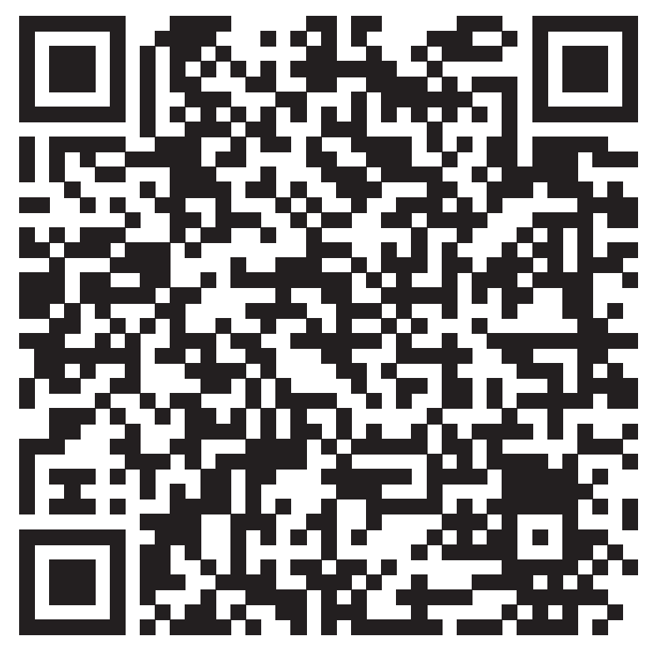
Attachment: Official Identification by Species
SB/sl

